**Assignment 5:**

Create a Employee Database for an organization. Each employee may or may not have a manager. One

employee may have many subordinates. This can grow upto any level. Write SQL schemas for MySQL and

load the tables with dummy data.

**Assumptions**

1. Employee Schema contains ID (primary key), name, designation and email

2. One employee shall have only one manager.

**Table Schema:**

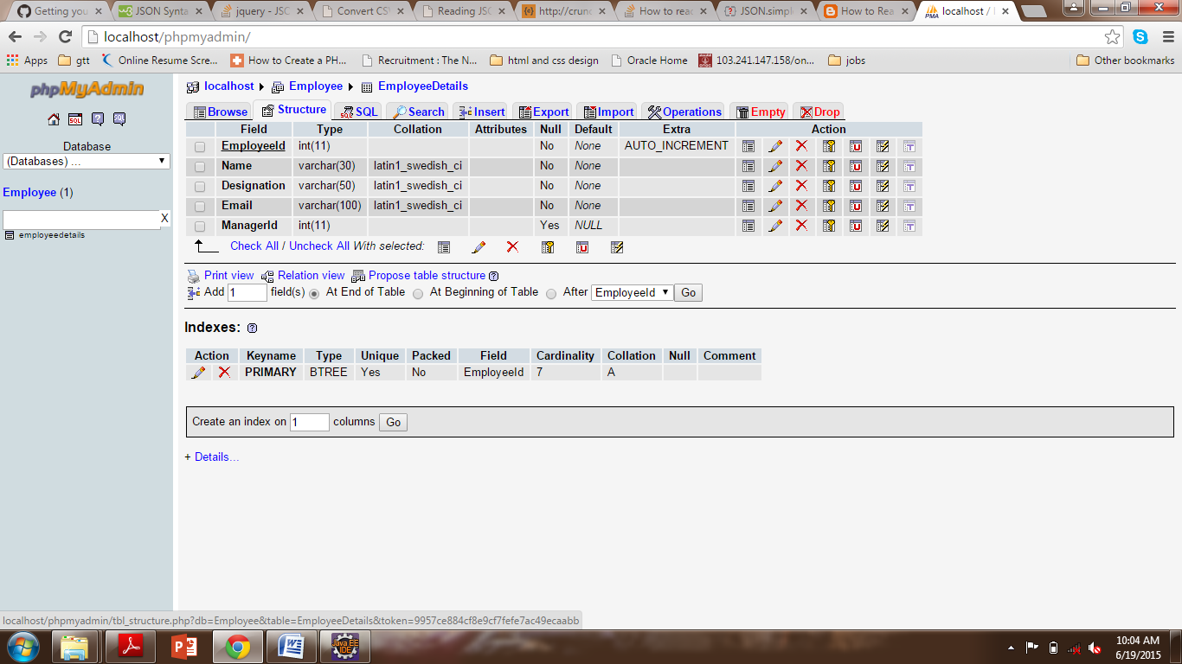

1. **Find all the sub-ordinates for a given employee**

SELECT * FROM EmployeeDetails WHERE ManagerId=6

1. **Find the manager of an employee**

SELECT name FROM EmployeeDetails WHERE employeeId=(select managerId from EmployeeDetails where EmployeeId=5)